Homework 4

Jiaqi Li

1.

(a) τ1 + τ2 – 2τ3  = 1(μ + τ1) + 1(μ + τ2 ) – 2(μ + τ3 )

Here, b1 = 1, b2 =1, b3 =–2

Thus, τ1 + τ2 – 2τ3 is estimable.

The LSE is:

τ̂1  + τ̂2 –2τ̂3 = Y̅1∙ +Y̅2∙ – 2Y̅3∙

(b) μ + τ3 = 0 (μ + τ1) + 0(μ + τ2 ) + 1(μ + τ3 )

Here, b1 = 0, b2 =0, b3 =1

Thus, μ + τ3 is estimable.

The LSE is:

μ̂ + τ̂­3 = Y̅3∙

(c) τ1 – τ2 – τ3

Since it cannot be written as a function of $\sum_{i=1}^{3}{b_{i}(μ+τ_{i})}$, it is not estimable.

(d) μ + (τ1 + τ2 + τ3)/3 = (μ + τ1) + (μ + τ2 ) + (μ + τ3 )

Here, b1 = b2 = b3 =

Thus, μ + (τ1 + τ2 + τ3)/3 is estimable.

The LSE is:

μ̂ + (τ̂ 1 + τ̂ 2 + τ̂ 3)/3 = Y̅1∙ + Y̅2∙ + Y̅3∙

2.

(a)

**The ANOVA model is:**

**Yit = μ + τi + ϵit i=1,2,3 t=1,2,3,4**

**ϵit ∼ N(0, σ2), where ϵit are iid.**

(b)

**LSEdeodorant = μ̂ + τ̂2 = Y̅2∙ = = 2.7**

(c)

**τregular – (τdeodorant + τmoisturizing )/2 = 1(μ + τregular ) – (μ + τdeoderant ) – (μ + τmoisturizing )**

Thus, τregular – (τdeodorant + τmoisturizing )/2 is **estimable** where b1 =1, b2 =– , b3 =–

LSE = τ̂regular – (τ̂deodorant + τ̂moisturizing )/2 = Y̅1∙ – Y̅2∙ – Y̅3∙

= – × – ×

=-0.035 – 1.35 – 0.99625 = –2.38125

**The LSE of τregular – (τdeodorant + τmoisturizing )/2 is –2.38125**

(d)

> type=c(rep("Regular",4),rep("Deordorant",4),rep("Moisturizing",4))

> cube=1:12

> weightloss=c(-0.30,-0.10,-0.14,0.40,2.63,2.61,2.41,3.15,1.86,2.03,2.26,1.82)

>

> experiment=data.frame(type,weightloss)

> experiment

type weightloss

1 Regular -0.30

2 Regular -0.10

3 Regular -0.14

4 Regular 0.40

5 Deordorant 2.63

6 Deordorant 2.61

7 Deordorant 2.41

8 Deordorant 3.15

9 Moisturizing 1.86

10 Moisturizing 2.03

11 Moisturizing 2.26

12 Moisturizing 1.82

>

> aov.experiment=aov(weightloss~type)

> aov.experiment

Call:

aov(formula = weightloss ~ type)

Terms:

type Residuals

Sum of Squares 16.122050 0.694575

Deg. of Freedom 2 9

Residual standard error: 0.2778039

Estimated effects may be unbalanced

>

> lsm.experiment=lsmeans(aov.experiment, "type")

> lsm.experiment

type lsmean SE df lower.CL upper.CL

Deordorant 2.7000 0.1389019 9 2.385782 3.014218

Moisturizing 1.9925 0.1389019 9 1.678282 2.306718

Regular -0.0350 0.1389019 9 -0.349218 0.279218

Confidence level used: 0.95

> contrast(lsm.experiment,list("Regular.minus.(Deoderant.plus.Moisturizing).divided.by.2"=c(-1/2,-1/2,1)))

contrast estimate SE

Regular.minus.(Deoderant.plus.Moisturizing).divided.by.2 -2.38125 0.1701194

df t.ratio p.value

9 -13.998 <.0001

**By looking at the chart, we have:**

**μ̂ + τ̂2  = 2.7000**

**τ̂regular – (τ̂deodorant + τ̂moisturizing )/2 = -2.38125**

**These data are the same as I calculated in part(b) and part(c).**

3.

(a)

> push=c(rep("0",7),rep("1",10),rep("2",10),rep("3",5))

> time=c(38.14,38.20,38.31,38.14,38.29,38.17,38.20,38.28,38.17,38.08,38.25,38.18,38.03,37.95,38.26,38.30,38.21,38.17,38.13,38.16,38.30,38.34,38.34,38.17,38.18,38.09,38.06,38.14,38.30,38.21,38.04,38.37)

> experiment.light=data.frame(push,time)

> experiment.light

push time

1 0 38.14

2 0 38.20

3 0 38.31

4 0 38.14

5 0 38.29

6 0 38.17

7 0 38.20

8 1 38.28

9 1 38.17

10 1 38.08

11 1 38.25

12 1 38.18

13 1 38.03

14 1 37.95

15 1 38.26

16 1 38.30

17 1 38.21

18 2 38.17

19 2 38.13

20 2 38.16

21 2 38.30

22 2 38.34

23 2 38.34

24 2 38.17

25 2 38.18

26 2 38.09

27 2 38.06

28 3 38.14

29 3 38.30

30 3 38.21

31 3 38.04

32 3 38.37

>

> as.numeric(experiment.light$push)

[1] 1 1 1 1 1 1 1 2 2 2 2 2 2 2 2 2 2 3 3 3 3 3 3 3 3 3 3 4 4 4 4 4

>

> plot(time~push,main="Plot of Waiting Time Against Number of Pushes")

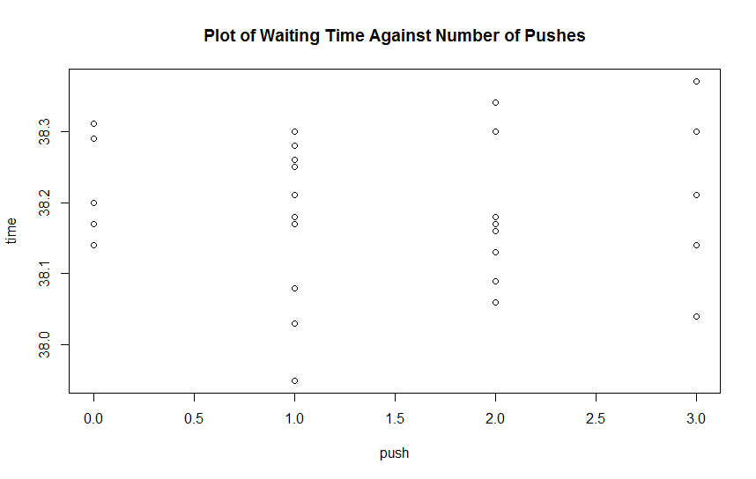

**The graph shows that each treatment has approximately the same median, and treatment 1, 2, 3 have approximately the same range of IQR while treatment 1 has comparatively smaller range of IQR.**

(b)

**The ANOVA model is:**

**Yit = μ + τi + ϵit i=0,1,2,3 t=1,2,3,4**

**ϵit ∼ N(0, σ2), where ϵit are iid.**

(c)

> mean.0=mean(time[push=="0"])

> mean.0

[1] 38.20714

> mean.1=mean(time[push=="1"])

> mean.1

[1] 38.171

> mean.2=mean(time[push=="2"])

> mean.2

[1] 38.194

> mean.3=mean(time[push=="3"])

> mean.3

[1] 38.212

**The mean waiting times for 0, 1, 2, 3 pushes are 38.20714, 38.171, 38.194, 38.212**

**Y̅0∙ = 38.20714**

**Y̅1∙ = 38.171**

**Y̅2∙ = 38.194**

**Y̅3∙ = 38.212**

(d)

**τ1 – τ0 = 0(μ + τ3) + 0(μ + τ2) + 1(μ + τ1) – 1(μ + τ0)**

Thus, τ1 – τ0 is **estimable** where b0=-1, b1=1, b2=0, b3=0

> aov.light=aov(time~push)

> aov.light

Call:

aov(formula = time ~ push)

Terms:

push Residuals

Sum of Squares 0.00804714 0.30595286

Deg. of Freedom 3 28

Residual standard error: 0.1045318

Estimated effects may be unbalanced

> lsm.light=lsmeans(aov.light, "push")

> lsm.light

push lsmean SE df lower.CL upper.CL

0 38.20714 0.03950929 28 38.12621 38.28807

1 38.17100 0.03305584 28 38.10329 38.23871

2 38.19400 0.03305584 28 38.12629 38.26171

3 38.21200 0.04674802 28 38.11624 38.30776

Confidence level used: 0.95

> contrast(lsm.light,list("1.minus.0"=c(-1,1,0,0)))

contrast estimate SE df t.ratio p.value

1.minus.0 -0.03614286 0.05151381 28 -0.702 0.4887

**Thus, the LSE is:**

**τ̂1 – τ̂0 = -0.03614286**

(e)

**(τ1 + τ2 + τ3)/3 ­– τ0 = (μ + τ3) + (μ + τ2) + (μ + τ1) – 1(μ + τ0)**

Thus, (τ1 + τ2 + τ3)/3 ­– τ0 is **estimable** where b0=-1, b1=, b2=, b3=

> contrast(lsm.light,list("(1.plus.2.plus.3).divided.by.3.minus.0"=c(-1,1/3,1/3,1/3)))

contrast estimate SE df t.ratio p.value

(1.plus.2.plus.3).divided.by.3.minus.0 -0.01480952 0.04523962 28 -0.327 0.7458

**Thus, the LSE is:**

**(τ̂1 + τ̂2 + τ̂3)/3 ­– τ̂0 = -0.01480**

**R code:**

**install.packages("lsmeans")**

**library(lsmeans)**

**#2-------------------------------------------------------------------------------**

**type=c(rep("Regular",4),rep("Deordorant",4),rep("Moisturizing",4))**

**cube=1:12**

**weightloss=c(-0.30,-0.10,-0.14,0.40,2.63,2.61,2.41,3.15,1.86,2.03,2.26,1.82)**

**experiment=data.frame(type,weightloss)**

**experiment**

**aov.experiment=aov(weightloss~type)**

**aov.experiment**

**lsm.experiment=lsmeans(aov.experiment, "type")**

**lsm.experiment**

**contrast(lsm.experiment,list("Regular.minus.(Deoderant.plus.Moisturizing).divided.by.2"=c(-1/2,-1/2,1)))**

**#3------------------------------------------------------------------------------**

**push=c(rep("0",7),rep("1",10),rep("2",10),rep("3",5))**

**time=c(38.14,38.20,38.31,38.14,38.29,38.17,38.20,38.28,38.17,38.08,38.25,38.18,38.03,37.95,38.26,38.30,38.21,38.17,38.13,38.16,38.30,38.34,38.34,38.17,38.18,38.09,38.06,38.14,38.30,38.21,38.04,38.37)**

**experiment.light=data.frame(push,time)**

**experiment.light**

**as.numeric(experiment.light$push)**

**plot(time~push,main="Plot of Waiting Time Against Number of Pushes")**

**aov.light=aov(time~push)**

**aov.light**

**mean.0=mean(time[push=="0"])**

**mean.0**

**mean.1=mean(time[push=="1"])**

**mean.1**

**mean.2=mean(time[push=="2"])**

**mean.2**

**mean.3=mean(time[push=="3"])**

**mean.3**

**lsm.light=lsmeans(aov.light, "push")**

**lsm.light**

**contrast(lsm.light,list("1.minus.0"=c(-1,1,0,0)))**

**contrast(lsm.light,list("(1.plus.2.plus.3).divided.by.3.minus.0"=c(-1,1/3,1/3,1/3)))**